PRT Maker:

Setup:

Extract the zip file into a directory where you would like to keep the program permanently – the BVQX folder in My Documents may be a good place as other BV scripts can be found there.

In Matlab, go to File → Set Path, a dialog box should open up. On the left hand side of the dialog box there is a group of buttons, click the button that says Add Folder. Search for the folder containing PRT Maker then click OK. There’s a Save button at the bottom, click it. This allows you to run PRT Maker by simply typing it in the command window without using the PRT Maker directory as your working directory. The advantage of this is that when you’re in the directory with your data and you run PRT_maker, you won’t have to surf through directories to find the EXCEL files.

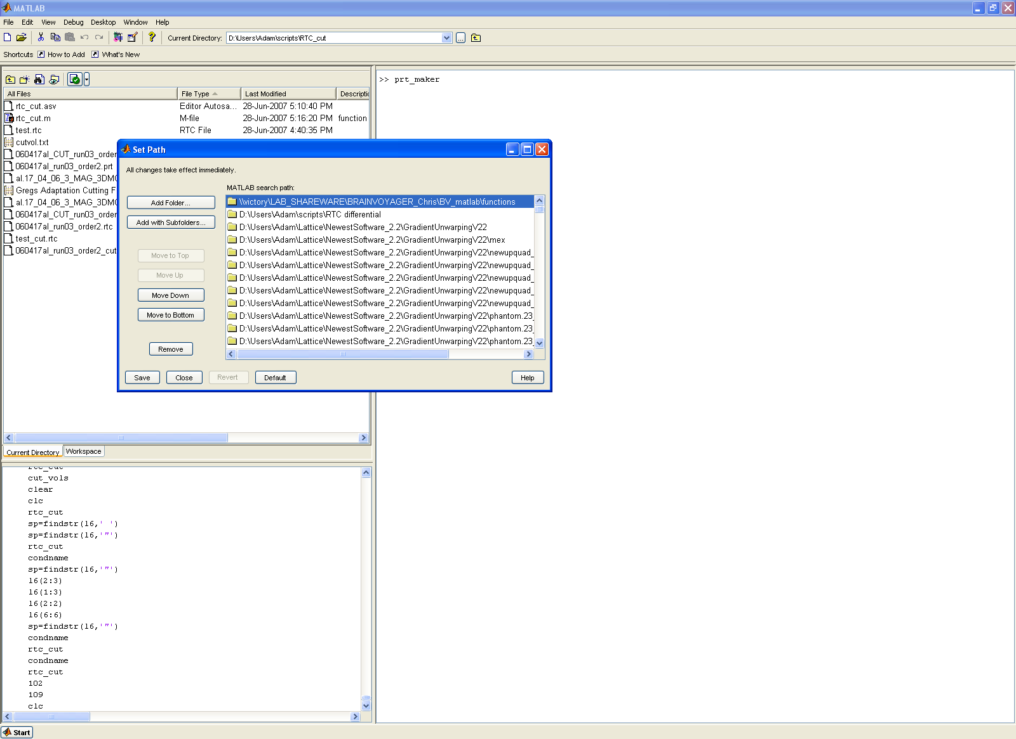

To run PRT maker, in MATLAB, go to the directory where your EXCEL files are found. You can do this with the Current Directory pull down menu found just below the menu bar at the top of the screen or with the Current Directory/Workspace window (shown by the yellow arrows in the figure below).

After choosing your directory, type in “prt_maker” (with the underscore!) in the command window and follow the instructions (Red arrow).

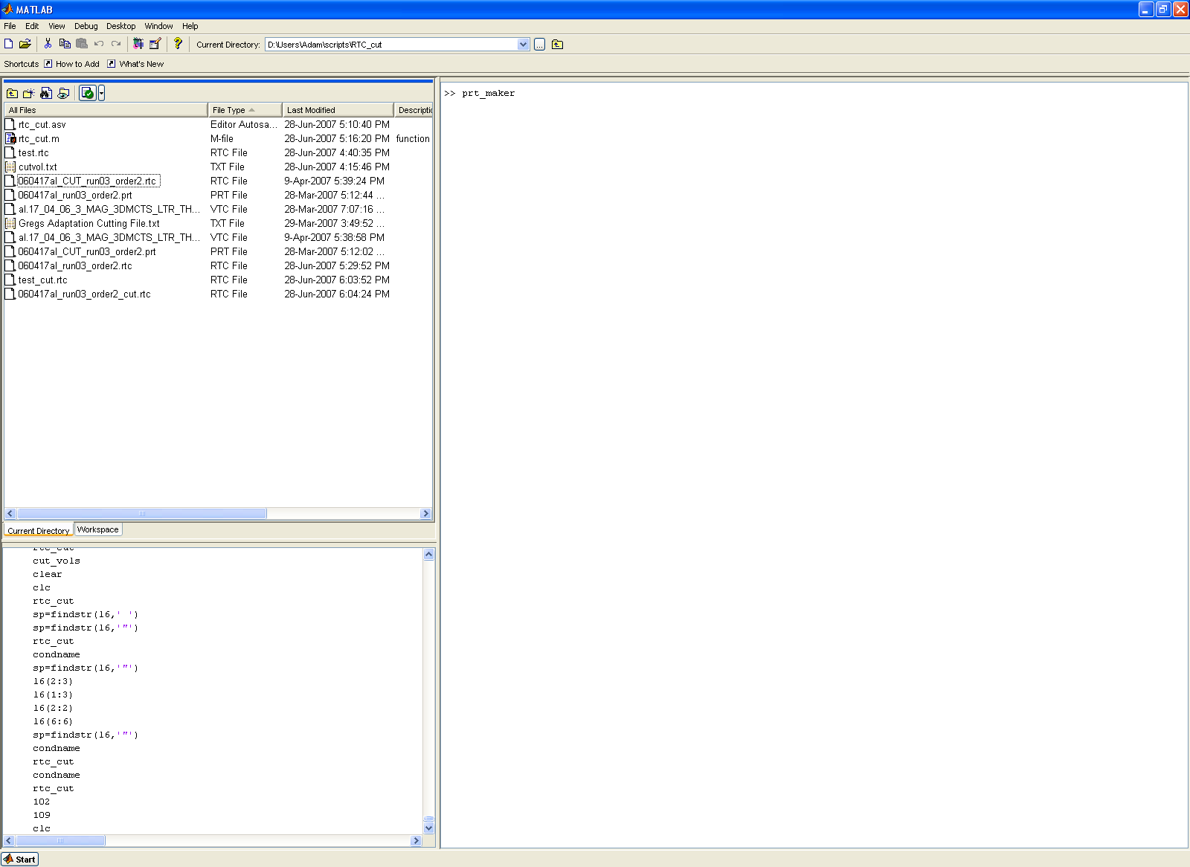

The EXCEL file:

PRT basically works by comparing the list of your conditions to the conditions in the runs. The order of the conditions in the first column is the order in which the conditions will be appear in your PRT file in Brain Voyager.

- Since the program works on comparisons, it is important that the spelling of all the conditions in your runs match those in the list of conditions otherwise they won’t be tallied properly in the prt output file.

The setup can be seen in the sample file, ‘test excel.xls’

The first row is reserved for the titles of the columns. DO NOT exclude this from the EXCEL file otherwise you won’t know what the rows mean in 6 months time and more importantly, the PRT maker program won’t work properly.

The first column is a list of all of the conditions. The order in which they are presented here is the order in which they appear in BV. List your baseline condition first or last depending on how you like to set things up in BV. If you don’t exclude any runs in BV, this is not a big concern for you.

The second column just assigns a numerical value to the state. This information is not used in the program but it needs to be included as this is how many people traditionally set up their worksheets so I kept it that way.

The 3rd and 4th columns are the start and stop times/volumes for your experiment. You can use both time or volume as your units and the program will ask you which you are using.

The rest of the columns are the condition orders presented in each run. You can have as many as you like here. MAKE SURE THE SPELLING HERE MATCHES THE SPELLING IN YOUR FIRST COLUMN. If, when you open up the prt file in BV and there are blanks in your paradigm, you most likely have a spelling mistake. Go back and check the EXCEL file.

The title in the first row of each column here will be added to the title of the file when PRT maker runs. For instance, with the test_excel file if you chose ‘test’ as your filename (when PRT_maker prompts you) the output files would be:

Test_Adam #1.prt, test_Adam #2.prt, test_Suzy #1.prt and test_Suzy #2.prt.

Finally, EXCEL gives you the option of including multiple worksheets in each file. To simplify things, prt_maker will only choose the first worksheet to read. It may be best just to make a separate file if you’re unsure how to switch the order of the worksheets in EXCEL.

That’s it. I hope you enjoy it.

If you are having any troubles with your setup, feel free to email me the EXCEL file and I’ll try to figure out the problem. If you have any suggestions or ways to improve the program, I’d be happy to incorporate them.

Adam McLean
amclean@imaging.robarts.ca

